Morning Prayer * 17 January 2021 * Second Sunday after the Epiphany
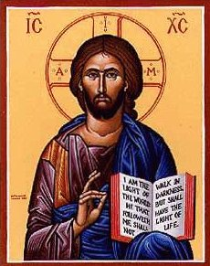

Words of Welcome and Logistics from Vicar Lauren
I will give you as a light to the nations, that my salvation may
reach to the end of the earth. Isaiah 49:6.

Confession and Absolution
The grace of God has dawned upon the world
through our Saviour Jesus Christ.
Silence may be kept.
You raise the dead to life in the Spirit:
Lord, have mercy.
Lord, have mercy.
You bring pardon and peace to the broken in heart:
Christ, have mercy.
Christ, have mercy.
You make one by your Spirit the torn and divided:
Lord, have mercy.
Lord, have mercy.

May the God of all healing and forgiveness
draw you to himself
and cleanse you from all your sins,
that you may behold the glory of his Son,
the Word made flesh,
Jesus Christ our Lord.
Amen.
The Invitatory and Psalm
Lord, open our lips.
And our mouth shall proclaim your praise.
Glory to the Father, and to the Son, and to the Holy Spirit: *
as it was in the beginning, is now, and will be for ever. Amen. Alleluia.

Psalm 139:1-5, 12-17
Domine, probasti
1 Lord, you have searched me out and known me; *
you know my sitting down and my rising up;
you discern my thoughts from afar.
2 You trace my journeys and my resting-places *
and are acquainted with all my ways.
3 Indeed, there is not a word on my lips, *
but you, O Lord, know it altogether.
4 You press upon me behind and before *
and lay your hand upon me.
5 Such knowledge is too wonderful for me; *
it is so high that I cannot attain to it.
12 For you yourself created my inmost parts; *
you knit me together in my mother's womb.
13 I will thank you because I am marvelously made; *
your works are wonderful, and I know it well.
14 My body was not hidden from you, *
while I was being made in secret
and woven in the depths of the earth.
15 Your eyes beheld my limbs, yet unfinished in the womb;
all of them were written in your book; *
they were fashioned day by day,
when as yet there was none of them.
16 How deep I find your thoughts, O God! *
how great is the sum of them!
17 If I were to count them, they would be more in number than the sand; *
to count them all, my life span would need to be like yours.
Silence is kept.
Now it is time to awake out of sleep,
For the night is far spent and the day is at hand.
Now is our salvation nearer than when we first believed,
For the night is far spent and the day is at hand.

The Readings
Lector: A Reading from I Samuel.
Now the boy Samuel was ministering to the Lord under Eli. The word of the Lord was rare in those days; visions were not widespread.
At that time Eli, whose eyesight had begun to grow dim so that he could not see, was lying down in his room; the lamp of God had not yet gone out, and Samuel was lying down in the temple of the Lord, where the ark of God was. Then the Lord called, “Samuel! Samuel!” and he said, “Here I am!” and ran to Eli, and said, “Here I am, for you called me.” But he said, “I did not call; lie down again.” So he went and lay down. The Lord called again, “Samuel!” Samuel got up and went to Eli, and said, “Here I am, for you called me.” But he said, “I did not call, my son; lie down again.” Now Samuel did not yet know the Lord, and the word of the Lord had not yet been revealed to him. The Lord called Samuel again, a third time. And he got up and went to Eli, and said, “Here I am, for you called me.” Then Eli perceived that the Lord was calling the boy. Therefore Eli said to Samuel, “Go, lie down; and if he calls you, you shall say, ‘Speak, Lord, for your servant is listening.’” So Samuel went and lay down in his place.
Now the Lord came and stood there, calling as before, “Samuel! Samuel!” And Samuel said, “Speak, for your servant is listening.” [Then the Lord said to Samuel, “See, I am about to do something in Israel that will make both ears of anyone who hears of it tingle.”
Lector: Here ends the Lesson.
Lector: A Reading from the first chapter of the Gospel according to St. John.
Jesus decided to go to Galilee. He found Philip and said to him, “Follow me.” Now Philip was from Bethsaida, the city of Andrew and Peter. Philip found Nathanael and said to him, “We have found him about whom Moses in the law and also the prophets wrote, Jesus son of Joseph from Nazareth.” Nathanael said to him, “Can anything good come out of Nazareth?” Philip said to him, “Come and see.” When Jesus saw Nathanael coming toward him, he said of him, “Here is truly an Israelite in whom there is no deceit!” Nathanael asked him, “Where did you get to know me?” Jesus answered, “I saw you under the fig tree before Philip called you.” Nathanael replied, “Rabbi, you are the Son of God! You are the King of Israel!” Jesus answered, “Do you believe because I told you that I saw you under the fig tree? You will see greater things than these.” And he said to him, “Very truly, I tell you, you will see heaven opened and the angels of God ascending and descending upon the Son of Man.”
Lector: Here ends the reading.
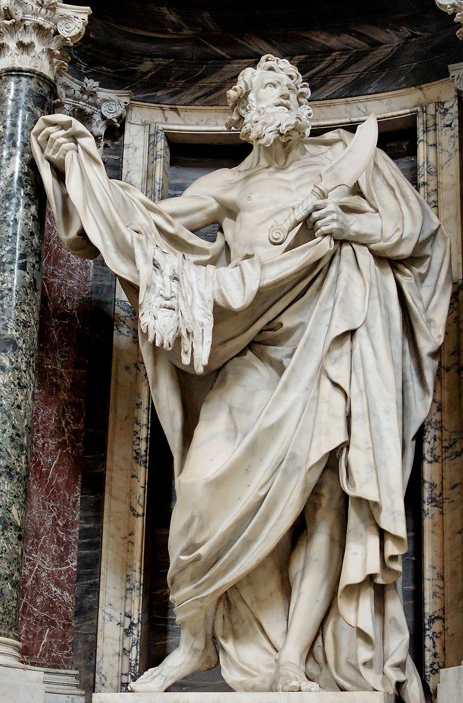
The Homily * Vicar Lauren
The Creed
I believe in God, the Father almighty,
creator of heaven and earth.
I believe in Jesus Christ, his only Son, our Lord.
He was conceived by the power of the Holy Spirit
and born of the Virgin Mary.
He suffered under Pontius Pilate,
was crucified, died, and was buried.
He descended to the dead.
On the third day he rose again.
He ascended into heaven,
and is seated at the right hand of the Father.
He will come again to judge the living and the dead.
I believe in the Holy Spirit,
the holy catholic Church,
the communion of saints,
the forgiveness of sins,
the resurrection of the body,
and the life everlasting. Amen.

The Lord be with you.

And also with you.

Let us pray.

Our Father, who art in heaven,
hallowed be thy name;
thy kingdom come;
thy will be done;
on earth as it is in heaven.
Give us this day our daily bread.
And forgive us our trespasses,
as we forgive those who trespass against us.
And lead us not into temptation;
but deliver us from evil.
For thine is the kingdom,
the power and the glory,
for ever and ever.
Amen.

O Lord, show thy mercy upon us;
And grant us thy salvation.
Endue thy ministers with righteousness;
And make thy chosen people joyful.
Give peace, O Lord, in all the world;
For only in thee can we live in safety.
Lord, keep this nation under thy care;
And guide us in the way of justice and truth.
Let thy way be known upon earth;
Thy saving health among all nations.
Let not the needy, O Lord, be forgotten;
Nor the hope of the poor be taken away.
Create in us clean hearts, O God;
And sustain us with thy Holy Spirit.
The Collect of the Day
Almighty God, whose Son our Savior Jesus Christ is the light of the world: Grant that your people, illumined by your Word and Sacraments, may shine with the radiance of Christ's glory, that he may be known, worshipped, and obeyed to the ends of the earth; through Jesus Christ our Lord, who with you and the Holy Spirit lives and reigns, one God, now and for ever. Amen.
A prayer, by Alcuin of York (8th c.) for the season of Epiphany
Eternal Light, shine into our hearts.
Eternal Goodness, deliver us from evil.
Eternal Power, be our support.
Eternal Wisdom, scatter our ignorance.
Eternal Pity, have mercy upon us.
That with all our heart and mind and soul and strength
we may seek your face
and be brought by your infinite mercy to your holy presence;
through Jesus Christ our Lord. Amen.
<please unmute yourself here!>
The General Thanksgiving
Almighty God, Father of all mercies, we your unworthy servants give you humble thanks for all your goodness and loving-kindness to us and to all whom you have made.
We bless you for our creation, preservation,
and all the blessings of this life;
but above all for your immeasurable love
in the redemption of the world
by our Lord Jesus Christ;
for the means of grace, and for the hope of glory.
And, we pray, give us such an awareness of your mercies,
that with truly thankful hearts
we may show forth your praise,
not only with our lips, but in our lives,
by giving up our selves to your service,
and by walking before you
in holiness and righteousness all our days;
through Jesus Christ our Lord,
to whom, with you and the Holy Spirit,
be honor and glory throughout all ages. Amen.
Let us bless the Lord.
Thanks be to God.
The grace of our Lord Jesus Christ, and the love of God, and the fellowship of the Holy Spirit, be with us all evermore. Amen. (2 Corinthians 13:14)
<take five minutes to fill up a mug, and then return to your Zoom for coffee hour!>

