Holy Eucharist
5January 2021Anno DominiTwelfth Night
St. Paul’s Episcopal Church, Louisburg, North Carolina
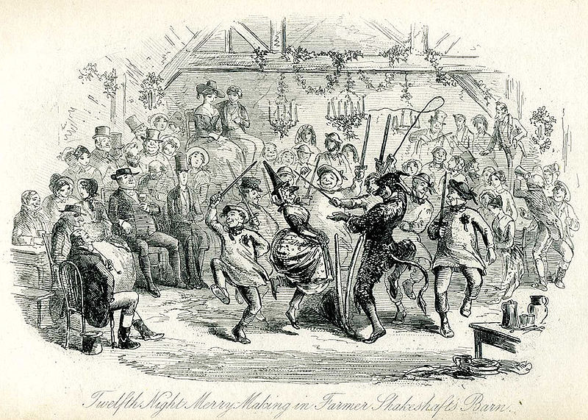

The people standing.

Blessed are you, Lord our God, King of the universe.
All From the rising of the sun to its setting
your name is proclaimed in all the world.

The Lord of glory be with you.
All And also with you.

Almighty God, to you all hearts are open, all desires known, and from you no secrets are hid: Cleanse the thoughts of our hearts by the inspiration of your Holy Spirit, that we may perfectly love you, and worthily magnify your holy Name; through Christ our Lord. Amen.

Glory to God in the highest, and peace to his people on earth. Lord God, heavenly King, almighty God and Father, we worship you, we give you thanks, we praise you for your glory. Lord Jesus Christ, only Son of the Father, Lord God, Lamb of God, you take away the sin of the world: have mercy on us; you are seated at the right hand of the Father: receive our prayer. For you alone are the Holy One, you alone are the Lord, you alone are the Most High, Jesus Christ, with the Holy Spirit, in the glory of God the Father. Amen.

Grateful for the glory revealed today through God made flesh, let us pray.
Silence is kept.
O God,
who by the leading of a star
manifested your only Son to the peoples of the earth:
mercifully grant that we,
who know you now by faith,
may at last behold your glory face to face;
through Jesus Christ your Son our Lord,
who is alive and reigns with you,
in the unity of the Holy Spirit,
one God, now and for ever.
All Amen.

The Readings from the Scriptures
Lector A reading from the sixtieth chapter ofIsaiah.
Arise, shine; for your light has come,
and the glory of the Lord has risen upon you.
For darkness shall cover the earth,
and thick darkness the peoples;
but the Lord will arise upon you,
and his glory will appear over you.
Nations shall come to your light,
and kings to the brightness of your dawn.
Lift up your eyes and look around;
they all gather together, they come to you;
your sons shall come from far away,
and your daughters shall be carried on their nurses' arms.
Then you shall see and be radiant;
your heart shall thrill and rejoice,
because the abundance of the sea shall be brought to you,
the wealth of the nations shall come to you.
A multitude of camels shall cover you,
the young camels of Midian and Ephah;
all those from Sheba shall come.
They shall bring gold and frankincense,
and shall proclaim the praise of the Lord.
The Word of the Lord.
Thanks be to God.

Psalm 72:1-7,10-14 * Deus, judicium
1 Give the King your justice, O God, *
and your righteousness to the King's Son;
2 That he may rule your people righteously *
and the poor with justice;
3 That the mountains may bring prosperity to the people, *
and the little hills bring righteousness.
4 He shall defend the needy among the people; *
he shall rescue the poor and crush the oppressor.
5 He shall live as long as the sun and moon endure, *
from one generation to another.
6 He shall come down like rain upon the mown field, *
like showers that water the earth.
7 In his time shall the righteous flourish; *
there shall be abundance of peace till the moon shall be no more.
10 The kings of Tarshish and of the isles shall pay tribute, *
and the kings of Arabia and Saba offer gifts.
11 All kings shall bow down before him, *
and all the nations do him service.
12 For he shall deliver the poor who cries out in distress, *
and the oppressed who has no helper.
13 He shall have pity on the lowly and poor; *
he shall preserve the lives of the needy.
14 He shall redeem their lives from oppression and violence, *
and dear shall their blood be in his sight.

The Holy Gospel of our Lord Jesus Christ according to St. Matthew. Glory to you, Lord Christ.
In the time of King Herod, after Jesus was born in Bethlehem of Judea, wise men from the East came to Jerusalem, asking, "Where is the child who has been born king of the Jews? For we observed his star at its rising, and have come to pay him homage." When King Herod heard this, he was frightened, and all Jerusalem with him; and calling together all the chief priests and scribes of the people, he inquired of them where the Messiah was to be born. They told him, "In Bethlehem of Judea; for so it has been written by the prophet:
`And you, Bethlehem, in the land of Judah,
are by no means least among the rulers of Judah;
for from you shall come a ruler
who is to shepherd my people Israel.'"
Then Herod secretly called for the wise men and learned from them the exact time when the star had appeared. Then he sent them to Bethlehem, saying, "Go and search diligently for the child; and when you have found him, bring me word so that I may also go and pay him homage." When they had heard the king, they set out; and there, ahead of them, went the star that they had seen at its rising, until it stopped over the place where the child was. When they saw that the star had stopped, they were overwhelmed with joy. On entering the house, they saw the child with Mary his mother; and they knelt down and paid him homage. Then, opening their treasure chests, they offered him gifts of gold, frankincense, and myrrh. And having been warned in a dream not to return to Herod, they left for their own country by another road.
The Gospel of the Lord. Praise to you, Lord Christ.
The Homily
The Nicene CreedWe believe in one God,the Father, the Almighty,maker of heaven and earth,of all that is, seen and unseen.We believe in one Lord, Jesus Christ,the only Son of God,eternally begotten of the Father,God from God, Light from Light,true God from true God,begotten, not made,of one Being with the Father.Through him all things were made.For us and for our salvationhe came down from heaven:by the power of the Holy Spirithe became incarnate from the Virgin Mary,and was made man.For our sake he was crucified under Pontius Pilate;he suffered death and was buried.On the third day he rose againin accordance with the Scriptures;he ascended into heavenand is seated at the right hand of the Father.He will come again in glory to judge the living and the dead,and his kingdom will have no end.We believe in the Holy Spirit, the Lord, the giver of life, who proceeds from the Father and the Son.With the Father and the Son he is worshiped and glorified.He has spoken through the Prophets.We believe in one holy catholic and apostolic Church.We acknowledge one baptism for the forgiveness of sins.We look for the resurrection of the dead,and the life of the world to come. Amen.
Prayers of the People
Join me in the prayers of the people.
Father, the wise men came from the east to worship your Son:
grant to Christians everywhere a true spirit of adoration.
Lord, in your mercy
All hear our prayer.
Father, your Son is the King of kings and Lord of lords:
grant an abundance of peace to your world.
Lord, in your mercy
All hear our prayer.
Father, the Holy Family shared the life of the people of Nazareth:
protect in your mercy our neighbours and families,
together with the whole community of which we are part.
Lord, in your mercy
All hear our prayer.
Father, your Son was rich, yet for our sakes he became poor:
show your love for the poor and powerless,
and strengthen those who suffer.
Lord, in your mercy
All hear our prayer.
Father, the wise men presented to your Son gold, incense and myrrh:
accept the gifts we bring,
and the offering of our hearts at the beginning of this new year.
Lord, in your mercy
All hear our prayer.
Father, you are the King of heaven, the hope of all who trust in you:
give to the faithful departed
the wonders of your salvation.
Lord, in your mercy
All hear our prayer.
Rejoicing in the fellowship of wise men, shepherds and angels,
and of the Blessed Virgin Mary and Saint Joseph,
we commend ourselves and all Christian people
to your unfailing love.
Merciful Father,
All accept these prayers
for the sake of your Son,
ourSaviour Jesus Christ.Amen.

The Peace

Our Saviour Christ is the Prince of Peace.
Therefore, may the peace of the Lord be always with you
All and also with you.
Lord, accept your people’s gifts,
not gold, frankincense or myrrh,
but hearts and voices raised in praise of Jesus Christ,
our light and our salvation.
All Amen.

The Lord be with you.And also with you.
Lift up your hearts.We lift them to the Lord.
Let us give thanks to the Lord our God.It is right to give God thanks and praise.

And now we give you thanks,
for by the leading of a star
you have revealed your only Son to the world,
that in following him
we are led from darkness into his marvellous light.

Holy, Holy, Holy Lord, God of power and might,heaven and earth are full of your glory.Hosanna in the highest.Blessed is he who comes in the name of the Lord.Hosanna in the highest.

Holy and gracious Father: In your infinite love you made us for yourself, and, when we had fallen into sin and become subject to evil and death, you, in your mercy, sent Jesus Christ, your only and eternal Son, to share our human nature, to live and die as one of us, to reconcile us to you, the God and Father of all.He stretched out his arms upon the cross, and offeredhimself,in obedience to your will, a perfect sacrifice for the whole world.On the night he was handed over to suffering and death, our Lord Jesus Christ took bread; and when he had given thanks to you, he broke it, and gave it to his disciples, and said, "Take, eat: This is my Body, which is given for you. Do this for the remembrance of me."

After supper he took the cup of wine; and when he had given thanks, he gave it to them, and said, "Drink this, all of you: This is my Blood of the new Covenant, which is shed for you and for many for the forgiveness of sins. Whenever you drink it, do this for the remembrance of me."

Therefore we proclaim the mystery of faith:

Christ has died.Christ is risen.Christ will come again.

We celebrate the memorial of our redemption, O Father, in this sacrifice of praise and thanksgiving. Recalling his death, resurrection, and ascension, we offer you these gifts.Sanctify them by your Holy Spirit to be for your people the Body and Blood of yourSon, the holy food and drink of new and unending life in him. Sanctify us also that we may faithfully receive this holy Sacrament, and serve you in unity, constancy, and peace; and at the last day bring us with all your saints into the joy of your eternalkingdom. All this we ask through your Son Jesus Christ: By him, andwith him, and in him, in the unity of the Holy Spirit all honor and glory is yours, Almighty Father, now and for ever. AMEN.

And now, as our Savior Christ has taught us, we are bold to say,Our Father, who art in heaven,hallowed be thy Name, thy kingdom come, thy will be done, on earth as it is in heaven. Give us this day our daily bread. And forgive us our trespasses, as we forgive those who trespass against us. And lead us not into temptation, but deliver us from evil. For thine is the kingdom, and the power, and the glory, for ever and ever. Amen.

The Celebrant breaks theconsecrated Bread.A period of silence is kept.

Alleluia. Christ our Passover is sacrificed for us;
Therefore let us keep the feast. Alleluia.

The Gifts of God for the People of God. Take them in remembrance that Christ died foryou, and feed on him in your hearts by faith, with thanksgiving.

Vicar Lauren will bring a consecrated wafer to you at your spot. After she has departed from your spot, remove your mask –ideally removing only one earloop – and take the body of Christ. Then immediately replace your mask.

Let us pray.
Lord God,the bright splendour whom the nations seek:
may we who with the wise men have been drawn by your light
discern the glory of your presence in your Son,
the Word made flesh, Jesus Christ our Lord.
All Amen.

The priest blesses the people.
May God, who led the wise men by the shining of a star
to find the Christ, the Light from light,
lead you in your pilgrimage to find the Lord.
And the blessing of God almighty,
the Father, the Son, and the Holy Spirit,
be among you and remain with you always.
All Amen.

Let us go forth in the name of Christ. Thanks be to God!

