Morning Prayer * 3 January 2021 * Second Sunday of Christmas
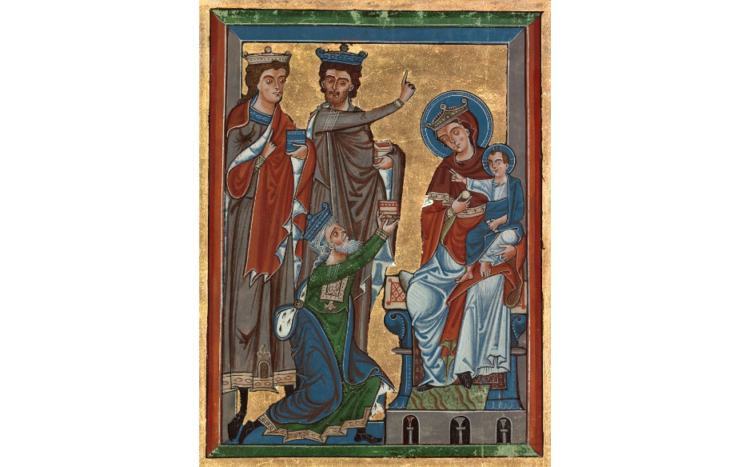
German Psalter ~1240

Words of Welcome and Logistics from Vicar Lauren

Behold, I bring you good news of a great joy, which will come
to all the people; for unto you is born this day in the city of
David, a Savior, who is Christ the Lord. Luke 2:10, 11

Confession and Absolution

Hear the words of the angel to Joseph:
‘You shall call his name Jesus,
for he will save his people from their sins.’
Therefore let us seek the forgiveness of God
through Jesus the Saviour of the world.

Silence may be kept.
God our Father,
you sent your Son full of grace and truth:
forgive our failure to receive him.
Lord, have mercy.
Jesus our Saviour,
you were born in poverty and laid in a manger:
forgive our greed and rejection of your ways.
Christ, have mercy.
Spirit of Love,
your servant Mary responded joyfully to your call:
forgive the hardness of our hearts.
Lord, have mercy.

May the God of all healing and forgiveness
draw you to himself
and cleanse you from all your sins,
that you may behold the glory of his Son,
the Word made flesh,
Jesus Christ our Lord.
Amen.
The Benedicte
Lord, open our lips.
And our mouth shall proclaim your praise.
Glory to the Father, and to the Son, and to the Holy Spirit: *
as it was in the beginning, is now, and will be for ever. Amen. Alleluia.

Glorify the Lord, all you works of the Lord,
praise him and highly exalt him for ever.
In the firmament of his power, glorify the Lord,
praise him and highly exalt him for ever.

Glorify the Lord, you angels and all powers of the Lord,
O heavens and all waters above the heavens,
Sun and moon and stars of the sky, glorify the Lord,
praise him and highly exalt him for ever.

Glorify the Lord, every shower of rain and fall of dew,
all winds and fire and heat.
Winter and summer, glorify the Lord,
praise him and highly exalt him for ever.

Glorify the Lord, O chill and cold,
drops of dew and flakes of snow.
Frost and cold, ice and sleet, glorify the Lord,
praise him and highly exalt him for ever.

Glorify the Lord, O nights and days,
O shining light and enfolding dark.
Storm clouds and thunderbolts, glorify the Lord,
praise him and highly exalt him for ever.

Let the earth glorify the Lord,
praise him and highly exalt him for ever.
Glorify the Lord, O mountains and hills,
and all that grows upon the earth,
praise him and highly exalt him for ever.

Glorify the Lord, O springs of water, seas, and streams,
O whales and all that move in the waters,
All birds of the air, glorify the Lord,
praise him and highly exalt him for ever.

Glorify the Lord, O beasts of the wild,
and all you flocks and herds,
O men and women everywhere, glorify the Lord
praise him and highly exalt him for ever.
Let the people of God glorify the Lord,
praise him and highly exalt him for ever.

Glorify the Lord, O priests and servants of the Lord,
praise him and highly exalt him for ever.
Glorify the Lord, O spirits and souls of the righteous,
praise him and highly exalt him for ever.
You that are holy and humble of heart, glorify the Lord,
praise him and highly exalt him for ever.

Silence is kept.
Now it is time to awake out of sleep,
For the night is far spent and the day is at hand.
Now is our salvation nearer than when we first believed,
For the night is far spent and the day is at hand.

The Readings
Lector: A Reading from the first chapter of Ephesians.
Blessed be the God and Father of our Lord Jesus Christ, who has blessed us in Christ with every spiritual blessing in the heavenly places, just as he chose us in Christ before the foundation of the world to be holy and blameless before him in love. He destined us for adoption as his children through Jesus Christ, according to the good pleasure of his will, to the praise of his glorious grace that he freely bestowed on us in the Beloved.
I have heard of your faith in the Lord Jesus and your love toward all the saints, and for this reason I do not cease to give thanks for you as I remember you in my prayers. I pray that the God of our Lord Jesus Christ, the Father of glory, may give you a spirit of wisdom and revelation as you come to know him, so that, with the eyes of your heart enlightened, you may know what is the hope to which he has called you, what are the riches of his glorious inheritance among the saints, and what is the immeasurable greatness of his power for us who believe.
Lector: Here ends the Lesson.
fromthe Benedicte
Glorify the Lord, O chill and cold,
drops of dew and flakes of snow.
Frost and cold, ice and sleet, glorify the Lord,
praise him and highly exalt him for ever.

Glorify the Lord, O nights and days,
O shining light and enfolding dark.
Storm clouds and thunderbolts, glorify the Lord,
praise him and highly exalt him for ever.
Glory to the Father, and to the Son, and to the Holy Spirit
as it was in the beginning, is now, and will be for ever. Amen.
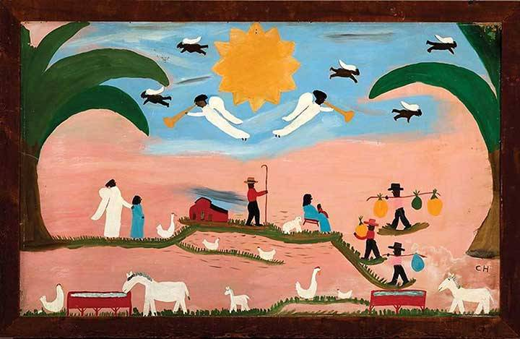
Clementine Hunter, “The Annunciation and the Adoration of the Wise Men,” 1957.
Lector: A Reading from the second chapter of the Gospel according to St. Matthew.
In the time of King Herod, after Jesus was born in Bethlehem of Judea, wise men from the East came to Jerusalem, asking, "Where is the child who has been born king of the Jews? For we observed his star at its rising, and have come to pay him homage." When King Herod heard this, he was frightened, and all Jerusalem with him; and calling together all the chief priests and scribes of the people, he inquired of them where the Messiah was to be born. They told him, "In Bethlehem of Judea; for so it has been written by the prophet:
`And you, Bethlehem, in the land of Judah,
are by no means least among the rulers of Judah;
for from you shall come a ruler
who is to shepherd my people Israel.'"
Then Herod secretly called for the wise men and learned from them the exact time when the star had appeared. Then he sent them to Bethlehem, saying, "Go and search diligently for the child; and when you have found him, bring me word so that I may also go and pay him homage." When they had heard the king, they set out; and there, ahead of them, went the star that they had seen at its rising, until it stopped over the place where the child was. When they saw that the star had stopped, they were overwhelmed with joy. On entering the house, they saw the child with Mary his mother; and they knelt down and paid him homage. Then, opening their treasure chests, they offered him gifts of gold, frankincense, and myrrh. And having been warned in a dream not to return to Herod, they left for their own country by another road.
Lector: Here ends the reading.
The Homily * Vicar Lauren
The Creed
I believe in God, the Father almighty,
creator of heaven and earth.
I believe in Jesus Christ, his only Son, our Lord.
He was conceived by the power of the Holy Spirit
and born of the Virgin Mary.
He suffered under Pontius Pilate,
was crucified, died, and was buried.
He descended to the dead.
On the third day he rose again.
He ascended into heaven,
and is seated at the right hand of the Father.
He will come again to judge the living and the dead.
I believe in the Holy Spirit,
the holy catholic Church,
the communion of saints,
the forgiveness of sins,
the resurrection of the body,
and the life everlasting. Amen.

The Lord be with you.

And also with you.

Let us pray.

Our Father, who art in heaven,
hallowed be thy name;
thy kingdom come;
thy will be done;
on earth as it is in heaven.
Give us this day our daily bread.
And forgive us our trespasses,
as we forgive those who trespass against us.
And lead us not into temptation;
but deliver us from evil.
For thine is the kingdom,
the power and the glory,
for ever and ever.
Amen.

O Lord, show thy mercy upon us;
And grant us thy salvation.
Endue thy ministers with righteousness;
And make thy chosen people joyful.
Give peace, O Lord, in all the world;
For only in thee can we live in safety.
Lord, keep this nation under thy care;
And guide us in the way of justice and truth.
Let thy way be known upon earth;
Thy saving health among all nations.
Let not the needy, O Lord, be forgotten;
Nor the hope of the poor be taken away.
Create in us clean hearts, O God;
And sustain us with thy Holy Spirit.
The Collect of the Day
O God, who wonderfully created, and yet more wonderfully restored, the dignity of human nature: Grant that we may share the divine life of him who humbled himself to share our humanity, your Son Jesus Christ; who lives and reigns with you, in the unity of the Holy Spirit, one God, for ever and ever. Amen.
A Collect for Christmastide
Almighty God,
in the birth of your Son
you have poured on us the new light of your incarnate Word,
and shown us the fullness of your love:
help us to walk in his light and dwell in his love
that we may know the fullness of his joy;
who is alive and reigns with you,
in the unity of the Holy Spirit,
one God, now and for ever.Amen.

A Collect for the New Year

God and Father of our Lord Jesus Christ,
whose years never fail
and whose mercies are new each returning day:
let the radiance of your Spirit renew our lives,
warming our hearts and giving light to our minds;
that we may pass the coming year
in joyful obedience and firm faith;
through him who is the beginning and the end,
your Son, Christ our Lord,
who is alive and reigns with you,
in the unity of the Holy Spirit,
one God, now and for ever.
Amen.
The work of Christmas begins
When the carols have been stilled,
When the star-topped tree is taken down,
When family and friends are gone home;
When we are back to our schedules
The work of Christmas begins:
To welcome the refugee,
To heal a broken planet,
To feed the hungry,
To build bridges of trust, not walls of fear,
To share our gifts,
To seek justice and peace for all people,
To bring Christ’s light to the world.
(Michael Dougherty, a variation on Howard Thurman’s “When the Song of the Angels is Stilled”)

<please unmute yourself here!>
The General Thanksgiving
Almighty God, Father of all mercies, we your unworthy servants give you humble thanks for all your goodness and loving-kindness to us and to all whom you have made.
We bless you for our creation, preservation,
and all the blessings of this life;
but above all for your immeasurable love
in the redemption of the world
by our Lord Jesus Christ;
for the means of grace, and for the hope of glory.
And, we pray, give us such an awareness of your mercies,
that with truly thankful hearts
we may show forth your praise,
not only with our lips, but in our lives,
by giving up our selves to your service,
and by walking before you
in holiness and righteousness all our days;
through Jesus Christ our Lord,
to whom, with you and the Holy Spirit,
be honor and glory throughout all ages. Amen.
Let us bless the Lord.
Thanks be to God.
The grace of our Lord Jesus Christ, and the love of God, and the fellowship of the Holy Spirit, be with us all evermore. Amen. (2 Corinthians 13:14)
<take five minutes to fill up a mug, and then return to your Zoom for coffee hour!>

